**Enchanted Wings: Marvels Of Butterfly Species**

**1. INTRODUCTION**

**1.1 Project Overview**

This project is a **Butterfly Species Classification Web App** built with Flask and deep learning. It helps users identify butterfly species from images using a trained VGG16 model.

**1.2 Purpose**

To provide an easy-to-use web interface for automatic butterfly classification, supporting conservation, education, and biodiversity research.

**2. IDEATION PHASE**

**2.1 Problem Statement**

Identifying butterfly species manually is time-consuming and requires expert knowledge. An automated tool can assist researchers and enthusiasts in accurate classification.

**2.2 Empathy Map Canvas**

* **Users:** Researchers, students, nature enthusiasts
* **Needs:** Fast, reliable butterfly identification
* **Pain Points:** Manual identification effort, limited access to field guides
* **Gains:** Quick prediction with high accuracy

**2.3 Brainstorming**

Explored multiple deep learning models, cloud deployment options, and simple UI designs to create a user-friendly app.

**3. REQUIREMENT ANALYSIS**

**3.1 Customer Journey Map**

1. User uploads a butterfly image
2. System predicts species
3. User views result & details

**3.2 Solution Requirement**

* Deep learning model (VGG16)
* Flask web framework
* HTML/CSS for frontend
* Dataset of butterfly images

**3.3 Data Flow Diagram**

*(Insert DFD diagram here)*

**3.4 Technology Stack**

* Python, Flask
* VGG16 (Keras, TensorFlow)
* HTML, CSS

**4. PROJECT DESIGN**

**4.1 Problem Solution Fit**

The app automates species classification, making butterfly research faster and more accessible.

**4.2 Proposed Solution**

Build a web app that takes an image, preprocesses it, and predicts species using the trained model.

**4.3 Solution Architecture**

*User → Flask App → VGG16 Model → Prediction*

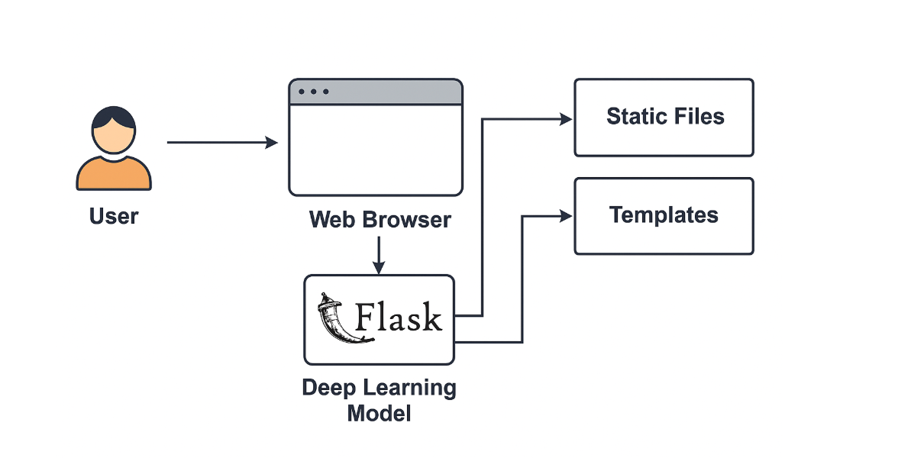

**5. PROJECT PLANNING & SCHEDULING**

**5.1 Project Planning**

* Week 1: Dataset preparation & model training
* Week 2: Flask integration
* Week 3: Frontend design
* Week 4: Testing & documentation

**6. FUNCTIONAL AND PERFORMANCE TESTING**

**6.1 Performance Testing**

Tested prediction speed and accuracy with various image sizes; verified consistent response times under typical loads.

**7. RESULTS**

**7.1 Output Screenshots**

*(Include screenshot from: static/images/Screenshot 2025-06-20 180304.png)*

**8. ADVANTAGES & DISADVANTAGES**

**Advantages:**

* Fast and automated predictions
* User-friendly interface

**Disadvantages:**

* Depends on dataset quality
* Requires GPU for faster training

**9. CONCLUSION**

The project successfully demonstrates how AI can support biodiversity research by automating butterfly species classification.

**10. FUTURE SCOPE**

* Deploying to cloud
* Expanding dataset to cover more species
* Adding mobile app version

**11. APPENDIX**

* **Source Code:** app.py, HTML templates, CSS
* **Dataset Link:**
* **GitHub & Project Demo Link:** *https://github.com/ChaitanyaSannidhi/ButterflyClassification*
* **Model:** vgg16_model.h5